Safeguarding Team – Suffolk & Essex
We have a statutory duty to safeguard and promote the welfare of children, young people and vulnerable adults. It is the responsibility of every member of staff, volunteer and visitor to Lapwing Education to ensure they work in a way that will safeguard and promote the welfare of all our students and project participants.

If you have any concerns about a student or project participant, you MUST share this information immediately with the Designated Safeguarding Lead (DSL) or one of the deputies.

Suffolk & Essex DSL | Charlotte Baker  Assistant Head of Education, Suffolk  Designated Safeguarding Lead (DSL)  Prevent Lead  Online Safety Lead  Designated Teacher for Children in Care  Tel: 07398 454211
Suffolk & Essex Deputy DSLs
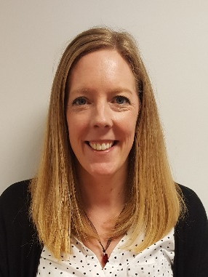 |  | 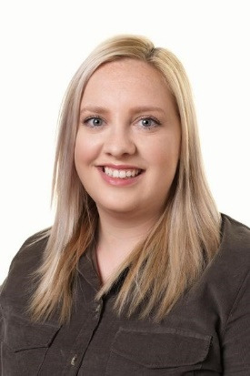
Lisa Squirrell  Head of Education, Suffolk  Deputy DSL  Tel: 07891 929869 | Will Fletcher  Chief Executive Officer  Deputy DSL  Health & Safety Lead  Data Protection Officer  Tel: 07501 969099 | Sarah Bowman  Assistant Head of Education, Suffolk  Deputy DSL  Tel: 07355 170145

