Minding The Gap case study: Chloe

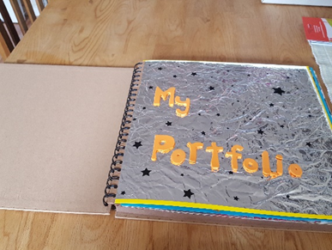  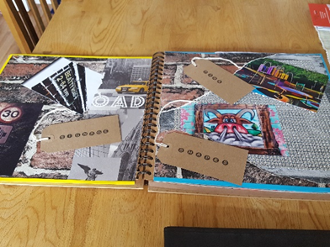  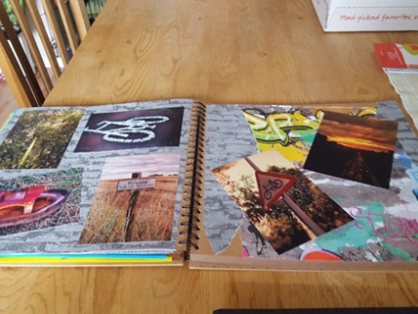 | Before joining the project, Chloe was economically inactive and socially isolated. She was struggling to manage her high anxiety and learning disabilities including dyspraxia and dyslexia. Chloe had previously dropped out of college after being unable to cope. She had no previous work experience and only a handful of poor GCSEs from secondary school.  Chloe had no ideas on what she wanted to do in the future and found it difficult to talk about her aspirations. There were, however, hints that she would enjoy working with animals or outdoors and we identified that she may be interested in photography.  A key worker from Lapwing was assigned to work with her and, over time, Chloe’s confidence, employability, practical skills and ability to socially interact steadily increased as she completed a range of activities including: a 6 week Green Light Trust conservation course; life skills including travel training, shopping and cooking - from being supported to independent; and an AQA unit award in digital photography producing an impressive portfolio. Chloe also started attending a local craft group, something she would never have done before her involvement with Lapwing.
Chloe successfully completed the project, enrolled onto a college course and is now working towards maths and English qualifications. At last Chloe is not afraid to dream big and now aspires to take photographs for National Geographic!

Chloe’s feedback on the project and Lapwing’s support:
“It has helped me to talk about myself and my feelings. It has given me the chance and confidence to do things. The keyworker gave me the backup needed with no pressure. I now know that I want to get into photography. I am definitely more prepared for work than I was, I am much happier, and I know what I am aiming for in life.”

